 | FOOD AND DRUGS AUTHORITY | DOC. TYPE: FORM
 |  | DOC NO.: FDA/FSMD/FM-FSE
 |  | PAGE 1 OF 4 | REV NO.: 00
 |  | EFFECTIVE DATE-04/2013
TITLE: APPLICATION FOR FOOD HYGIENE PERMIT

SECTION A – General Information (All applicants complete entire section- please print)
Purpose (check one)  
New Renewal Extensive Remodel   Change of owner/operator Reactivate
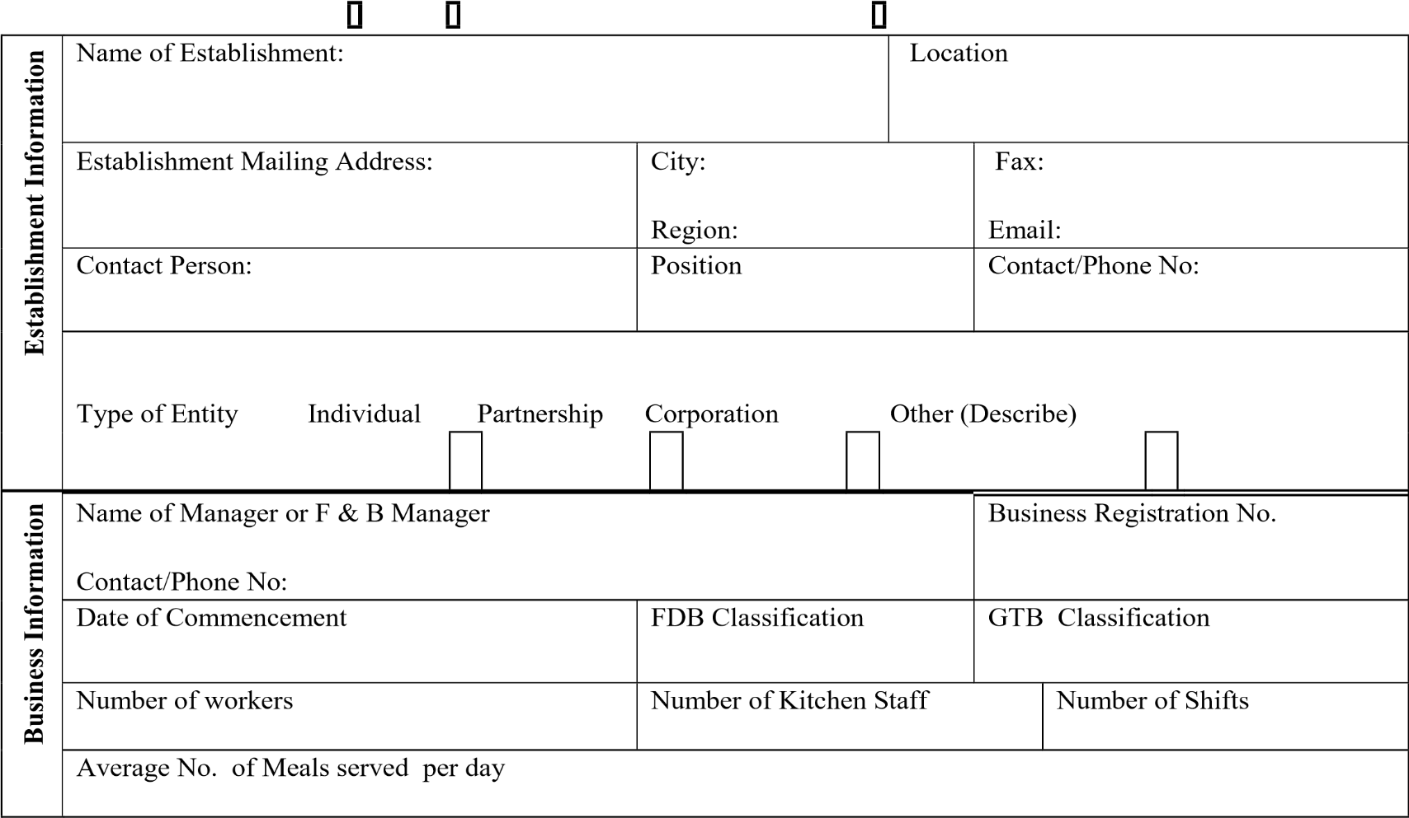

TYPES OF OPERATIONS (Check all that apply)
FOOD SERVICE | TYPES OF DISHES SERVED
Bar with Food Service  Contract Caterer  Hotel with Food Service  Mobile food unit  Restaurant  Takeout or Fast Food or Drive-in or Drive-thru  Other________________________ | Local  Continental  Chinese  Other________________________

SECTION B – Complete for ALL Food Establishments - Check all that apply

1.0 Preparation & Processing Methods:

Attach copy of proposed menu

Methods of food preparation (check the one that most closely describes the establishment):
Assembly of Ready-to-eat foods
Cook and Serve
Complex (Preparation 1 day or more in advance, cooling and reheating is done)
Hot or Cold Holding or service for 2 hr. or more

Style of Service: Counter Service Self-Service (i.e. Buffet line, salad bar)
Table Service Other
2.0 Equipment & Raw Materials

2.1 Equipment

Equipment Type | Number of Units
...................................................................... | ..........................................
...................................................................... | ..........................................
...................................................................... | ..........................................
. ...................................................................... | ..........................................
...................................................................... | ..........................................
2.2Type and sources of raw materials

Raw Material Type | Sources
...................................................................... | ..........................................
...................................................................... | ..........................................
. ...................................................................... | ..........................................
...................................................................... | ..........................................
...................................................................... | ..........................................
...................................................................... | ..........................................
. ...................................................................... | ..........................................
...................................................................... | ..........................................
(Attach details/additional information, where necessary)

3.0 Source of water:___________________________________________________________
3.1 Alternate Source of Water ___________________________________________
3.2 Storage System ___________________________________________
4.0 Type of water treatment system (If any):_________________________________________
_____________________________________________________________________________

5.0 CATERING:
List the equipment used to protect food from contamination and to maintain product temperature during:

5.1 Transportation_____________________________________________________________
_____________________________________________________________________________
_____________________________________________________________________________

5.2 Hot or cold holding ________________________________________________________
_____________________________________________________________________________
_____________________________________________________________________________

5.3 Describe sneeze guards or food protection devices to be used during display for self service:
_____________________________________________________________________________
_____________________________________________________________________________
_____________________________________________________________________________

6.0 Waste Management & Drainage System
6.1 Method of solid waste disposal ________________________________________________
_____________________________________________________________________________

6.2 Method of Liquid waste disposal ________________________________________________
_____________________________________________________________________________

7.0 Management Personnel
Personnel Qualification(s) Years of Experience
- Manager (F & B) ____________________  - Head, Chef ____________________  - Head, Procurement ____________________  - Head, Stores ____________________  - Proprietor/Owner/Director ____________________ 8.0 Any additional information: | _____________________  _____________________  _____________________  _____________________  _____________________
_____________________________________________________________________________
_____________________________________________________________________________
_____________________________________________________________________________

9.0 Enclosure
- Technical and/ or management agreement signed with any organization
- Building plans indicating machinery positions and sanitary facilities c. Site master file
- Certificate of Incorporation of Business
- Certificate of Commencement of Business
- Health or Food Handlers Test Certificate

I, hereby, declare that the information given on this application form is true and correct to the best of my knowledge.

............................................... …………………...............
Manager or F & B Manager Date

FOOD SERVICE ESTABLISHMENT LOCATION

- Name of Facility: ……………………………………………………………….……………………………
- Contact Number: (Landline)……………………….…… Mobile: …….…………………………….
- Postal Address: ………………………………………………………………...………………………………
- Contact Person: …………………………………………………………...…………………………………

- Position: ………………………………...……………Tel: ……………….…….…………………………….

Please sketch or attach exact direction to your facility, indicating landmarks, if any

