APPLICATION FORM FOR THE
REGISTRATION OF DIAPERS (BABY &
ADULT), SANITARY PADS AND MOP-
UP TOWELS

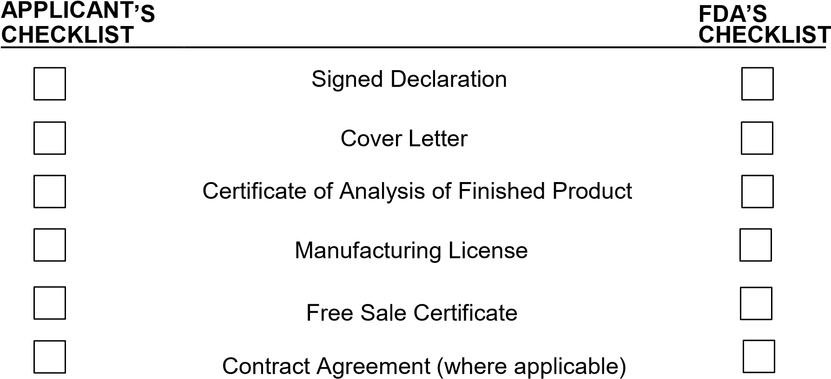

APPLICATION FOR THE REGISTRATION OF A MEDICAL DEVICE
(TO BE SUBMITTED IN ONE HARD COPY, ONE SOFT COPY)

A. COVER LETTER

Addressed to: THE CHIEF EXECUTIVE OFFICER FOOD AND DRUGS AUTHORITY P.
O. BOX CT 2783
CANTONMENTS, ACCRA, GHANA.

B. DETAILS OF APPLICANT

Name: …………………………………………………………………………………………..
Postal Address: ...............................................................................................................
............................................................................................................................. ............ ..................................................................................................................... ....................
Fax: ........................................................................................................................ .........
Tel. Nos. : ...................................................................................... .................................
E -mail: ............................................................................................................................. Website: ..........................................................................................................................

C. DETAILS OF MANUFACTURER

Name: ………………………………………………………………………………………….
Postal Address: ...............................................................................................................
.............................................................................................................................
............ .....................................................................................................................
...................
Location Address: …………………………………………………………………………….
............................................................................................................................. ...........
..............................................................................................................................
............ Fax:
.................................................................................................................................
Tel. Nos.: .................................................................................................................. ......
E -mail: ..............................................................................................................................
Website: .................................................................................................................... ......
Contact Person: ............................................................................................................... Tel. Nos.: .........................................................................................................................

D. DETAILS OF LOCAL AGENT

Name: ……………………………………………………………………… ……………………
Business Address: …........................................................................................................
…...................................................................................................................................... ....
.....................................................................................................................................
Fax: …..................................................................................................................... ..........

Tel. Nos.: …................................................................................................................. ....
E -mail: ….........................................................................................................................
Website: …................................................................................................................... ....
Contact Person: …....................................................................................... ....................
Tel. Nos. : …....................................................................................................................

Certified Copy of Power of Attorney (where applicable, to be attached)

E. DECLARATION

I/We, the undersigned, hereby declare that all the information contained herein is correct and true.
Name: …………… …………………………………………………………………………….
Position: ………………………………………………………………………………………..
Signature: …………………………….... Date: ………………………………………………

Official Stamp:

F. DETAILS OF THE MEDICAL DEVICE

i. Generic name: ……………………………………………………………………………. ii.
Brand name: ……………………………………………………………………………... iii.
Size(s): …………………………………….. Colour(s): …………………………………. iii.
Country of origin: ………………………………………………………………………… iv.
Commercial presentation: ………………………………………………………………. v.
Intended use of the device……………………………………………………………….
............................................................................................................................. .......... vi. Estimated shelf-life of the MedicalDevice.................................................................

- Has the registration of the device been rejected, refused, deferred or cancelled in any country?
YES NO

If YES, details.
.............................................................................................................................
............
.........................................................................................................................................

- Is the device manufactured in countries other than the country of origin?
YES NO

If YES, state details and list manufacturing plants from which imports can be made.
............................................................................................................................. ............
.........................................................................................................................................

Attach 4 (four) copies of labels*, package inserts and packaging materials proposed for marketing the product in Ghana.

* The text of labels and written material should conform to the existing labeling regulations (LI 1541).

