FOOD AND DRUGS AUTHORITY

APPLICATION FOR REGISTRATION OFAN
ALLOPATHIC DRUG
(to be submitted as two electronic copy (Modules 3-5 in pdf on a CD-Rom) including Modules 1 and 2 in MS-Word)

CONFIDENTIAL

THE CHIEF EXECUTIVE OFFICER,
FOOD AND DRUGS AUTHORITY P.O. BOX CT 2783 CANTONMENT-ACCRA GHANA.
Fax:
Telephone:
Mobile:
WEBSITE: www.fdaghana.gov.gh
For Inquiries email: fdaghana.gov.gh

Document No: FDA/DRI/DER/AP-RAD/2013/02
Date of First Adoption: 1st February 2013
Date of Issue: 1st March 2013
Version No: 01

For FDA use only

Application Number
Date of submission of the dossier
Name of the 1st Evaluator |  |  |  |  |  | Signature
Name of the 2nd Evaluator |  |  |  |  |  | Signature
Date of 1st evaluation
Date of 2nd Evaluation
Number of files and CD(s) received
CONCLUSION OF THE ASSESSMENT
RECOMMENDED (no outstanding issues)
QUERY RAISED (Indicate the sections where query is raised)
REJECTED (indicate the module(s) that led to the rejection)
(Please delete which does not apply)
TYPE OF APPLICATION – HUMAN, BIOLOGICAL OR VETERINARY PRODUCT
(Please delete / change which does not apply)
MODULE 1: ADMINISTRATIVE INFORMATION
SECTION 1: PARTICULARS OF THE PRODUCT
1.0 Attach a cover letter
1.1 Table of content of the application (MODULE 1-5)
1.2 Application Information
For FDA use only

1.2.1 | Trade Name/Proprietary of the product
For FDA use only

1.2.2 | Approved/International Non-proprietary Name (INN)/Generic name of the Active Pharmaceutical  Ingredient (API)
For FDA use only

1.2.3 | Dosage form and route of administration of the product:
For FDA use only

1.2.4 | Strength of API per unit dosage of the product
1.2.4.1 | Dosage form of the product:
1.2.4.2 | Route(s) of administration
For FDA use only

1.2.5 | Commercial presentation of the product:
For FDA use only

1.2.6 |  | Nature and content of container
1.2.7 |  | Description of the product (Add as many rows as necessary)

1.2.8 |  | Country of Origin
1.2.9 |  | Category of distribution
1.2.9.1 |  | POM (Prescription only medicine) (Please delete which does not apply)
1.2.9.2 |  | P (Pharmacist initiated medicine) (Please delete which does not apply)
1.2.9.3 |  | OTC (Over-the-counter medicine) (Please delete which does not apply)
1.2.9.4 |  | VETERINARY DRUGS
1.2.9.4.1 |  | Veterinary Medicines (VM) Prescription
1.2.9.4.2 |  | Veterinary Medicines (General Dealer) – (V.M.G.D)
1.2.10 |  | Pharmacological classification and indication
1.2.10.1 |  | Pharmacological classification
1.2.10.2 |  | Indication
For FDA use only

1.2.11 | Proposed shelf life (in months) and storage conditions:
1.2.11.1 | Proposed shelf life:
1.2.11.2 | Proposed shelf life (after reconstitution or dilution):
1.2.11.3 | Proposed storage conditions:
1.2.11.4 | Proposed storage conditions (after reconstitution or dilution):
For FDA use only

1.2.12 Name and address of Applicant
(Company) Name:
Address:
Country:
Telephone:
Telefax:
E-Mail:
For FDA use only

1.2.13 | Name(s) and complete address (es) of the manufacturer(s)
1.2.13.1 | Name(s) and complete address(es) of the manufacturer(s) of the finished pharmaceutical product (FPP), including the final product release if different from the manufacturer. (Add as many rows as necessary)
Name:
Company name:
Address:
Country:
Telephone:
Telefax:
E-Mail:
If the manufacturer is different to 1.1 above, explain the relationship:
1.2.13.2 | Name(s) and complete address(es) of the manufacturer(s) of the active pharmaceutical ingredient(s) (API) (Add as many rows as necessary)
Name:
Company name:
Address:
Country:
Telephone:
Telefax:
E-Mail:
1.2.14 Manufacturing and marketing authorisation(s)/international registration status
1.2.14.1 Product Marketing Authorisation issued by the national regulatory authority in the country of origin and other countries (If not registered in the country of origin state reasons).
Authorised | Withdrawn (by applicant after authorisation)
Country: | Country:
Date of authorisation (dd-mm-yyyy): | Date of withdrawal (dd-mm-yyyy):
Proprietary name: | Proprietary name:
Authorisation number: | Reason for withdrawal:
Refused | Suspended/revoked (by competent authority)
Country: | Country:
Date of refusal (dd-mm-yyyy): | date of suspension/revocation (dd-mm-yyyy):
Reason for Refusal: | Reason for suspension/revocation:
Proprietary name:
1.2.14.2 Attach a valid certificate of pharmaceutical product from the country of origin.
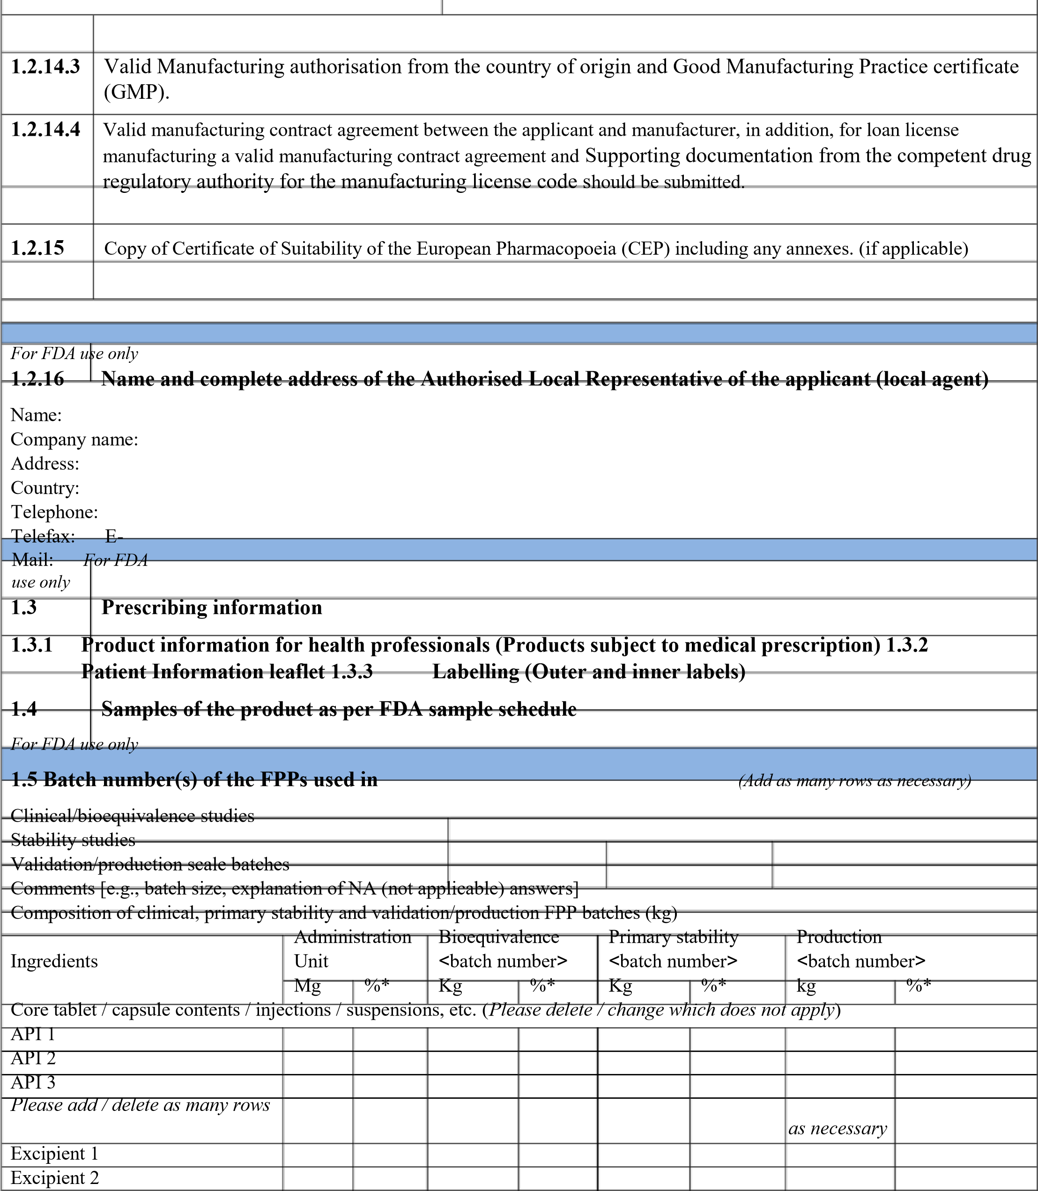
Excipient 3
Please add / delete as many rows as necessary
Subtotal 1
Purified water/other solvent(s)
Film coat / capsule shell / printing ink (Please delete / change which does not apply)
Proprietary film-coating mixture**
Please add / delete as many rows as necessary
Subtotal 2
Grand total

Purified water/other solvent(s)
Equivalence of the composition or justified differences |  |  |  | The compositions of the bioequivalence, stability and validation batches are the same and differences are justified. (Please delete / change which does not apply)
* Each ingredient is expressed as a percentage of the grand total.
** All components (……………..) of the proprietary mixture are described in the compendia
For FDA use only
OVERALL QUERIES AND RECOMMENDATIONS FOR THIS MODULE

MODULE 2: CHEMICAL, PHARMACEUTICAL, NON-CLINICAL AND CLINICAL
OVERVIEWS AND SUMMARIES
2.1 | CTD TABLE OF CONTENTS OF MODULES 2, 3, 4, AND 5
2.2 | INTRODUCTION
2.3 | QUALITY OVERALL SUMMARY
For FDA use only
2.3.S | OVERVIEW OF ACTIVE PHARMACEUTICAL INGREDIENT(S) [API(S)]
2.3.S.1 | General Information of the API(S)
2.3.S.1.1 | Nomenclature
For FDA use only
2.3.S.1.2 | Structure
For FDA use only
2.3.S.1.3 | General Properties of the API(s)
For FDA use only
2.3.S.2 | Manufacture of the API(S)
2.3.S.2.1 | Name and address of API(s) Manufacturer
For FDA use only
2.3.S.2.2 | Description of Manufacturing Process and Process Controls
2.3.S.2.3 | Control of Materials used in Manufacture of API
2.3.S.2.4 | Controls of Critical Steps and Intermediates
2.2.S.2.5 | Process Validation and/or Evaluation
For FDA use only
2.3.S.3 | Characterization of the API(S)
2.3.S.4 | Control of the API(S))
2.3.S.5 | Reference Standards or Materials of the API(S)
2.3.S.6 | Container Closure System of the API(S)
2.3.S.7 | Stability of the API(S)
For FDA use only
2.3.P | OVERVIEW OF FINISHED PHARMACEUTICAL PRODUCT [FPP]
2.3.P.1 | Description and Composition of the FPP
2.3.P.2 | Pharmaceutical Development of the FPP
2.3.P.3 | Manufacture of the FPP
2.3.P.4 | Control of Excipients for the FPP
2.3.P.5 | Control of the FPP
2.3.P.6 | Reference Standards or Materials of the FPP
2.3.P.7 | Container Closure System of the FPP
2.3.P.8 | Stability of the FPP
2.3. A | APPENDICES
 | REGIONAL INFORMATION
For FDA use only OVERALL QUERIES AND RECOMMENDATIONS FOR THIS MODULE

MODULE 3: CHEMICAL-PHARMACEUTICAL DOCUMENTATION
3.1 | TABLE OF CONTENTS OF MODULE 3
3.2 | BODY OF DATA
3.2.1 | PARTICULARS OF ACTIVE PHARMACEUTICAL INGREDIENT(s) [API(s)]
3.2.1.1 | General Information of the API(S)
3.2.1.2 | Manufacture of the API(S)
3.2.1.4 | Control of the API(S))
3.2.1.6 | Container Closure System of the API(S)
3.2.1.7 | Stability of the API(S)
3.2.2 | PARTICULARS OF FINISHED PHARMACEUTICAL PRODUCT(S) [FPP(S)]
3.2.2.1 | Description and Composition of the FPP(S)
3.2.2.3 | Manufacture of the FPP(S)
3.2.2.5 | Control of the FPP(S)
3.2.2.7 | Container Closure System of the FPP(S)
3.2.2.8 | Stability of the FPP(S)
DECLARATION BY AN APPLICANT
- I, the undersigned certify that all the information in this application form and accompanying documentation is correct, complete and true to the best of my knowledge.
- I further confirm that the information referred to in my application dossier is available for verification during current GMP inspection.
- The product shall not be imported, distributed for sale or advertised in Ghana until the product has been duly registered by the FDA.
- I also agree that the applicant will implement a Pharmacovigilance plan for this product in accordance with FDA requirements
- I also agree that I am obliged to follow the requirements of the FDA Act, which are related to pharmaceutical products.
- I also consent to the processing of information provided by the FDA.

Name: …………………………………………………………………..……………………….
Position in the company:………………………………………………………………………… Signature:
…………………………………………………………………………….…………
Date:………………………………………..
Official stamp:……………………………..

