 | FOOD AND DRUGS AUTHORITY | DOC. TYPE: FORM
 |  | DOC NO.: FDA/MDD/FOR-03
 |  | Page 1 of 8 | REV. NO.: 02
TITLE: APPLICATION FORM FOR THE REGISTRATION OF CLASS I MEDICAL DEVICES

APPLICATION FORM FOR THE
REGISTRATION OF CLASS I MEDICAL DEVICES

APPLICANT’S FDA’S CHECKLIST CHECKLIST
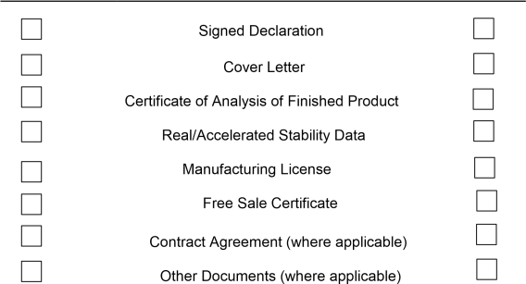

APPLICATION FOR THE REGISTRATION OF A MEDICAL DEVICE
(TO BE SUBMITTED IN ONE HARD COPY, ONE SOFT COPY)

A. COVER LETTER

Addressed to: THE CHIEF EXECUTIVE OFFICER FOOD AND DRUGS AUTHORITY P.
O. BOX CT 2783
CANTONMENTS,ACCRA,GHANA.

B. DETAILS OF APPLICANT

Name: ………………………………………………………………………………………..

Postal Address: ……………………………………………………………………………..
............................................................................................................................. .........
........................................................................................................................ ..............
......................................................................................................................................
Fax: . ........................................................................................................................
Tel. Nos. :......................................................................................................................
Email: …..............................................................................
.......................................... Website:
.......................................................................................................................

C. DETAILS OF MANUFACTURER
Name: ...………………………………………………… ……………...................................
Postal Address: ............................................................................................................
Location Address: .........................................................................................................
Fax: … ........................................................................................................................
Tel. Nos. : .....................................................................................................................
E-mail:…
....................................................................................................................... Website: ...................................................................................................................... Contact Person: ........................................................................................................... Tel. Nos. : .....................................................................................................................

D. DETAILS OF LOCAL AGENT

Name: ………………………………………………………………………………………….
Business Address : ……………………………………………………………………………
............................................................................................................................. ...........
...................................................................................................................... ..................
........................................................................................................................................
………………………………………………………………………………………………….. Fax: …………………………………………………………………………………………..... Tel. Nos.: ...................................................................................................................... Website: ......................................................................................................................
Email: ………………………………………………………………………………………….
Contact Person: .............................................................................................................
Tel. Nos.: ........................................................................................................................
Certified Copy of Power of Attorney (where applicable, to be attached)

E. DECLARATION

I/We, the undersigned, hereby declare that all the information contained herein is correct and true.

Name: …………………………………………………………………………………………

Position: ………………………………………………………………………………………

Signature: ………………….............. Date: ……………………………………………….

Official Stamp:

F. DETAILS OF THE MEDICAL DEVICE

i. Generic name: ………………………………………………………………………………… ii. Brand name:
………………………………………………………………………………….. iii.
Size(s)…………………………….Colour(s)………………………………………………... iv. Model/Series (If applicable):
………………………………………………………………..

v. Family (If applicable): ………………………………………………………………………... vi. Commercial presentation:
…………………………………………………………………..

vii. Country of origin: …………………………………………………………………………… viii. Intended use of the device:
........................................................................................
...........................................................................................................................................
.
...........................................................................................................................................
.

APPENDIX I
Manufacturing Procedure and Related Controls of Medical Device

1 . Details of manufacturing procedure and documentation
- Give a brief summary of the manufacturing process: …………………………………

…………………………………………………………………………………………………….

..........................................................................................................................................
.........………………………………………………………………………………………………

- Attach the final analytical report and authorisation for the release of the finished product
..........................................................................................................................................
..........................................................................................................................................

- Provide the estimated shelf-life of the Medical Device

......................................................................................................................................

- Attach Stability data and justification on which shelf-life has been predicated

...................................................................................................................................... ......................................................................................................................................
APPENDIX II
1. a. Has an application for the registration of the device been made in any other country?

YESNO

If YES, list the countries
......................................................................................................................................
.....................................................................................................................................
......................................................................................................................................

- Has the device been registered in the country of origin?
YES NO

If YES, attach a copy of certificates of registration in respect of such a device issued by the appropriate authority established for the registration of Medical Devices in the country. ...................................................................................................................................

- Has the registration of the device been rejected, refused, deferred or cancelled in any country?
YES NO

If YES, provide details.
......................................................................................................................................
......................................................................................................................................
......................................................................................................................................
2 . Is the device manufactured in countries other than the country of origin?
YES NO

If YES, state details and list manufacturing plants from which imports can be made.
......................................................................................................................................
......................................................................................................................................
......................................................................................................................................
Attach 4 (four) copies of labels*, package inserts and packaging materials proposed for marketing the product in Ghana.
* The text of labels and written material should conform to the existing labeling regulations (LI 1541).

