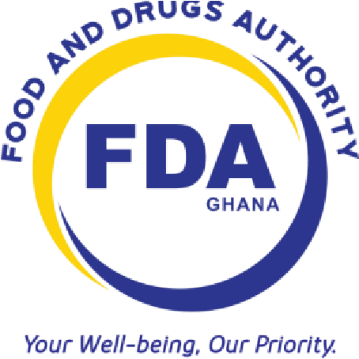

FOOD AND DRUGS AUTHORITY

GUIDELINE FOR DONATION OF DRUGS

Document No.: FDA/DRI/DER/GL-DOM/2019/13

Date of First Adoption: 15th March, 2019 Date of Issue: 15th March, 2019 Version No.: 01

FDA/DRI/DER/GL-DOM/2019/13

ACKNOWLEDGEMENT
The Food and Drugs Authority (FDA) acknowledges the Ministry of Health, Ghana in the development of this guideline.

i

TABLE OF CONTENTS
1. INTRODUCTION ................................................................................................................................ 1 2. GLOSSARY ........................................................................................................................................ 1 3. 0 REQUIREMENTS ................................................................................Error! Bookmark not defined. a. General 2
i. Principles of Good Donation 2
b. General Requirements 2
c. Specific Requirements 3
i. Registration 3
ii. Fees 4
iii. Letter 4
4. TIMELINES 4
5. PENALTIES 4

FDA/DRI/DER/GL-DOM/2019/13

1. INTRODUCTION

Drugs constitute an essential commodity in the delivery of effective health care. The safety, quality and efficacy of drugs are thus of importance in the regulatory framework. In pursuance of Section 148 of the Public Health Act, 2012, Act 851 these guidelines are hereby made for information, guidance and strict compliance by all concerned on the procedure and requirements for the donation of drugs in Ghana. These guidelines are applicable to drugs for use in humans as well as for veterinary use, where applicable.

These guidelines must be read and used in conjunction with the enabling legislation, the
Public Health Act, 2012, Act 851, Part 7, the current version of the Food and Drugs
Authority (FDA) Guideline for Registration of Allopathic Drugs, Biological Products, Vaccines and Veterinary Medicines as well as any other relevant Guidelines and Regulations issued by the FDA.

2. GLOSSARY

In these Guidelines, unless the context otherwise requires, the following terms have the assigned meanings:

- An Applicant: In this context refers to a manufacturer, the donor, or by an importer of the drugs. Such an applicant would be responsible for the product and all issues relating to the product, including any information accompanying the product.

- Authority: The Food and Drugs Authority, Ghana.

- “Drug” means
  - a substance referred to in a publication mentioned in the Fourth Schedule,
  - a substance or mixture of substances prepared, sold or represented for use in the:
- diagnosis, treatment, mitigation or prevention of disease, disorder of abnormal physical state or the symptoms of it, in man or animal, or
- restoring, correcting or modifying organic functions in man or animal, and nutritional supplements;

- Local Applicant: An applicant that is resident in Ghana.
Page 1 of 4

- Local Agent: A local agent is a person resident in Ghana or a corporate body registered in Ghana, with the relevant mandate from the applicant, to act on the applicant’s behalf as regards matters relating to the donation.

- Non-Resident applicant: An applicant applying for permit to donate products to Ghana but not a resident of Ghana.

3. 0 REQUIREMENTS

a. General

i. Principles of Good Donation

The four underlying principles, which form the core of Good Donation Practice, are:

- Drugs donations should benefit the recipient to the maximum extent possible.

- Donations should be given with due respect for the wishes and authority of the recipient, and in conformity with government policies and administrative arrangements of the recipient country.

- There should be no double standard in quality. If the quality of an item is unacceptable in the donor country, it is also unacceptable as a donation.

- There should be effective communication between the donor and the recipient, with all donations made according to a plan formulated by both parties.

b. General Requirements
- All donations should be based on an expressed need and be relevant to the disease pattern in Ghana. These should be based on existing and approved Selective List on Drugs.

- All donated items should appear on the national standards lists.

- Drugs or their generic equivalents should appear on the List of Essential Drugs.

- The specifications of donated items should be similar to those of items commonly used in Ghana.
- All product intended for donation shall have at least 60% of its shelf life remaining. This notwithstanding, products with a shelf life of less than 24 months shall have at least 80% of its shelf life remaining at the time of importation.
- Products requiring refrigeration or freezing for stability must specifically indicate storage requirements, both on labels and containers as well as on the documents and be shipped in special containers to ensure that the cold chain is maintained.

- In accordance with section 148 of the Public Health Act of 2012 (Act 851), the recipient is to ensure that a Qualified Person for Pharmacovigilance actively monitor and report all adverse drug reactions experienced accordingly to the Authority.

c. Specific Requirements

i. Registration

- A non-resident applicant would be required to appoint a local agent with the requisite mandate to represent the said applicant. For donation of drugs the local agent may be the recipient of the donated drugs. The agent would be required to produce the relevant documentation including, but not limited to, a power of attorney or any other documentation, affirming his/her appointment as an agent.

- Where the drug to be donated has been registered in Ghana by the FDA, the recipient of the donated item would be required to liaise with the Company that holds the market authorization in Ghana. This would be for the purposes of monitoring the safety of the drug.

- Where the drug is not registered in the country, the donation would be permitted only after the drug has been duly registered please refer to the FDA’s guidelines for the registration of the drug.

- Donations for products limited to be manufactured only by Local manufacturers cannot be imported for donations.

- An application for drug donations should include the packing list of the products. The packing list should include the Name of the Product, Manufacturer, Strength of the product, dosage form and the expiry dates of the items to be donated.

ii. Fees

- All fees in connection with the registration of drugs are specified in the current FDA Fee Schedule.

- No fee is Charged for processing applications for donation for registered products.

iii. Letter

All applications for processing of drug donations shall be made by submitting a letter addressed to:

The Chief Executive Officer
Food and Drugs Authority
P. O. Box CT 2783
Cantonments – Accra

4. TIMELINES

A minimum period of 1(one) month is to be allowed for the completion of the process.

5. PENALTIES

In line with the provisions of Section 129, Part 7, Act 851, the Public Health Act, 2012, a person who contravenes these Guidelines commits an offence and is liable on summary conviction:

- to a fine not less than seven thousand five hundred (7,500) penalty units and not more than Fifteen thousand penalty units (15,000), or

- to a term of imprisonment of not less than fifteen years and not more than twenty-five years, or to both

