FOOD AND DRUGS AUTHORITY

GUIDELINES FOR REPORTING ADVERSE REACTION

Document No. : FDA/SMC/SMD/GL-RAR/2013/01
Date of First Adoption : 1st February, 2013
Date of Issue : 1st March, 2013
Version No. : 04
Revision 1 : 31st May, 2015
Date of Adoption : 30th July, 2015
Revision 2 : 1st May, 2016
Revision 3 : 28th December, 2016

TABLE OF CONTENTS

1.0. INTRODUCTION 3
2.0. GLOSSARY 4
3.0. REQUIREMENTS 10
3.1. General Principles and Scope of Reporting 10
3.1.1. What to Report 10
3.1.2. Information to be provided on the Reporting Form 10
3.1.2.1. Patient Details 10
3.1.2.2. Reaction Details 10
3.1.2.3. Details of the Suspected Product 11
3.1.3. Reporter Details 11
3.1.4. How to Report 11
3.1.5. Confidentiality of ADR Reports 12
3.1.6. Follow-Up Information for an already Reported ADR 12
3.1.7. Reporting in Clinical Trials 12
3.1.8. Duplication of Report 12
3.2. Specific Requirements 13
3.2.1. Roles and Responsibilities 13
3.2.1.1. Local Representative or Marketing Authorization Holders 13
3.2.1.2. The Healthcare Professional 15
3.2.1.3. The Consumer 15
3.2.1.4. The Authority 15
4.0. TIMELINES 19
4.1. Reporting by Healthcare Professionals 19
4.2. Reporting by the Local Representatives or Marketing Authorization Holders 19
4.2.1 Other Sources of Reports 22
4.3. Reporting in Special Situations 22
4.3.1. Lack of Efficacy 22
4.3.2. Overdosage 23
4.4 Feedback on Reports Received 23
4.4.1 Adverse Reaction Reports 23
4.4.2 Risk Management Plans, PSURs (or PBRERs) 23
5.0. SANCTIONS 24
6.0. PENALTIES 24
APPENDIX I- Adverse Reaction Reporting Form 24
APPENDIX II-Patient Reporting Form 26
APPENDIX III- Addresses and Contacts of FDA Offices 28
APPENDIX IV- Summary of Timelines and Report Format 28

1.0. INTRODUCTION
In pursuance to Public Health Act 2012, Act 851, Part 7, Section 125, subsection, these guidelines are hereby promulgated for information, guidance and strict compliance by Healthcare Professionals, Local Representatives appointed by Marketing Authorization Holders and Manufacturers and the Food and Drugs Authority to help in the continuous safety monitoring of products granted marketing authorization in Ghana.

Products particularly medicines are registered for use based on satisfactory documentation, justifying the balance of benefits and risk within the conditions specified in the product labeling. The decision to approve products for use is based on the safety information available at the time of approval. The knowledge related to the safety profile of the product may change over time when the product is used in the general population. The safety monitoring of medicines is important for the following reasons;

1.1. Information collected during pre-marketing clinical trials of medicines are inevitably incomplete with regard to the possible adverse reactions.
1.2. In clinical trials patients are selected and limited in number and variability. The conditi ons of use differ from those in clinical practice and the duration of trials are limited.
1.3. Information about rare but serious adverse reactions, chronic toxicity, drug interaction s and use in special groups (such as children, the elderly or pregnant women) is often incomplete or not available.

The objective of safety monitoring is therefore to assess and monitor risks related to the utilization of products in humans, to implement measures to reduce such risks and to promote the proper and safe use of these products.

2.0. GLOSSARY
In these guidelines, unless the context otherwise states:

“Adverse Drug Reaction Report”
An adverse drug reaction report is a detailed record of all relevant data associated with the use of a medicine in a subject or patient.

“Adverse Drug Reaction (ADR) / Adverse Reaction”
A response to a medicinal product which is noxious and unintended including lack of efficacy and which occurs at any dosage and can arise from:
- The use of product within the terms of the marketing authorization
- The use of product outside the terms of the marketing authorization, including overdose, off-label use, misuse, abuse and medication errors;
- Occupational exposure

A reaction, contrary to an event is characterized by the occurrence of a suspected causal relationship between the drug and the reaction, as determined by the reporter or a reviewing health care professional. The fact that the health care professional is making a report to the Local Representative, the Marketing Authorization Holder or the Authority serves as an indication that the observed reaction may be caused by the medicine. All spontaneous reports are, therefore, suspected adverse drug reactions.

“Adverse Event (or adverse experience)”
“Adverse event/experience” is any untoward medical occurrence in a patient or clinical trial subject administered a product that may present during treatment with a medicine but which does not necessarily have a causal relationship with this treatment.

“Adverse Events Following Immunization (AEFI)”
An Adverse Event Following Immunization is any untoward medical occurrence which follows immunization and which does not necessarily have a causal relationship with the usage of the vaccine. The adverse event may be any unfavorable or unintended sign, abnormal laboratory finding, symptom or disease.

“Authority” means Food and Drugs Authority

“Consumer”
A person who is not a healthcare professional such as a patient, friend or relative of the patient.

“Drug Abuse”
Drug abuse is a persistent or sporadic, intentional excessive use of medicines, which is accompani ed by a harmful physical or psychological effects.

“Expedited Reporting”
This is the immediate reporting and in not more than 7 calendar days, of a serious adverse reaction to the Authority.

“Food supplements”
Concentrated sources of nutrients or other substances produced in a pharmaceutical dosage form such as tablets, gelatin capsules (soft or hard), sachets, syrups and powders. Dietary components include herbs, vitamins and minerals (with concentrations less than the recommended daily allowance), natural oils, royal jelly, pollen and bee propolis. All these ingredients can be included in a dietary supplement on the condition that their sole function is supplementation and improvement of body function.

“Healthcare professional”
A person who is a medically qualified person such as a physician, dentist, pharmacist or nurse.

“Local Representative”
The company or legal entity who represents the MAH in Ghana and perform functions delegated by the MAH.

“Local Distributor or Local Agent”
A company or legal entity appointed by the manufacturer or the Marketing Authorization Holder to import, receive as donation, distribute or sell a product in Ghana.

“Marketing Authorization Holder”
Marketing Authorization Holder: The company or legal entity in whose name the marketing authorization for a product has been granted and is responsible for all aspects of the product and compliance with the conditions of marketing authorization.

“Medication Errors”
Any preventable medication related event occurring as a result of actions by a healthcare professional that may cause or lead to patient harm while the patient is in the care of the healthcare professional.

“New Drug”
A chemical or biologically active pharmaceutical ingredient that has not previously been issued with a marketing authorization as an ingredient in any pharmaceutical product in Ghana.

“Overdose”
Accidental or intentional use of drug or medicine in an amount that is higher than is normally used. “Periodic Benefit Risk Evaluation Report (PBRER)”
An update of the world-wide marketing experience of a product at defined times with focus on formal evaluation of benefit in special population at defined times during post-registration period.

“Periodic Safety Update Report (PSUR)”
A regular update of the world-wide safety experience of a product at defined times during postregistration period.

“Pharmacovigilance”
The science and activities relating to the detection, assessment, understanding and prevention of adverse effects or any other possible drug-related problems.
Pharmacovigilance and Safety Monitoring are used interchangeably in this guideline.

“Product” means drugs, herbal medicinal products, cosmetics, medical devices and household chemical substances.

“Post Authorization Safety Study (PASS)”
Any study relating to an authorized product conducted with the aim of identifying, characterizing or quantifying a safety hazard, confirming the safety profile of the product, or of measuring the effectiveness of risk management measures.

“Qualified Person for Pharmacovigilance (QPPV)”
An individual named by a Marketing Authorization Holder (MAH) and approved by the Authority as the person responsible for ensuring that the company (the MAH) meets its legal obligations in the Public Health Act, 2012, Act 851 Section 125 for monitoring of the safety of the product marketed in Ghana.

“Risk Benefit Balance”
This is an evaluation of the positive therapeutic effects of the medical product in relation to the risks (any risk relating to the quality, safety or efficacy of the medical product as regards patients’ health or public health).

“Risk Management Plan”
A systematic approach and set of pharmacovigilance activities and interventions designed to identify, characterize, prevent or minimize risks relating to medical products, and the assessment of effectiveness of those interventions and how these risk will be communicated to the Authority and the general population.

“Serious Adverse Drug Reaction or Adverse Event”
A serious adverse event or reaction is any untoward medical occurrence that at any dose:
2.1. results in death;
2.2. is life threatening
2.3. requires inpatient hospitalisation or results in prolongation of existing hospitalisation;
2.4. results in persistent or significant disability/incapacity;
2.5. is a congenital anomaly/birth defect;
2.6. is a medically important event or reaction.

(NOTE: The term "life-threatening" in the definition of "serious" refers to an event/reaction in which the patient was at risk of death at the time of the event/reaction; it does not refer to an event/ reaction which hypothetically might have caused death if it were more severe);
Medical and scientific judgment should be exercised in deciding whether other situations should be considered serious such as important medical events that might not be immediately lifethreatening or result in death or hospitalisation but might jeopardise the patient or might require intervention to prevent one of the other outcomes listed in the definition above. Examples of such events are intensive treatment in an emergency room or at home for allergic bronchospasm, blood dyscrasias or convulsions that do not result in hospitalisation, or development of drug dependency or drug abuse.
The term “severe” is often used to describe the intensity (severity) of a specific event. This is not the same as “serious,” which is based on patient/event outcome or action criteria.

“Spontaneous Report or Spontaneous Notification”
Unsolicited communication by a patient, a consumer or healthcare professional to the Authority, marketing authorization holder or local representative or an organization that describes a suspected adverse reaction in a patient, a consumer who is given one or more medicines and which is not derived from a study or any organized data collection systems where adverse event reporting is actively sought.

“Unexpected Adverse Reaction”
An unexpected adverse reaction is one in which the nature, specificity, severity and outcome is not consistent with the applicable product information (i.e., with the approved package inserts for registered medicines, or the investigator’s brochure or other product information for unregistered medicines.

3.0. REQUIREMENTS

3.1. General Principles and Scope of Reporting

3.1.1. What to Report
For all products the following should be reported:
3.1.1.1. Adverse drug reactions (ADR) resulting from non-prescription and prescription drugs (including biological products and radiopharmaceutical products).
3.1.1.2. Adverse reactions resulting from herbal medicinal products and food supplements medical devices, cosmetics and household chemical substances.
3.1.1.3. Drug abuse, drug overdose, drug interactions, quality defects, poor packaging, questionable stability, suspected contamination, suspected counterfeit and lack of therapeutic efficacy.
3.1.1.4. Adverse events resulting from products used during phase IV clinical studies.
3.1.1.5. Adverse reactions occurring in a recipient of blood or blood components

3.1.2. Information to be provided on the Reporting Form

3.1.2.1. Patient Details
3.1.2.1.1. Age/Date of Birth,
3.1.2.1.2. Sex,
3.1.2.1.3. Weight,
3.1.2.1.4. Name of the health facility or treatment centre,
3.1.2.1.5. Folder number (name or any local identification number that will help identify the patient in case of follow-up) and telephone number of patient or nearest contact person.

3.1.2.2. Reaction Details
3.1.2.2.1. A detailed description of the suspected adverse drug reaction.
3.1.2.2.2. Information on dates of onset and stop of the reaction.
3.1.2.2.3. Outcome of the reaction (whether the patient has recovered, not recovered or the outcome unknown).
3.1.2.2.4. Treatment provided for the adverse reaction (if any).

3.1.2.3. Details of the Suspected Product
3.1.2.3.1. The name(s) of the suspected medicine(s).
Provide both the brand and the generic names of the product, batch number, Manufacturer, route of administration (if known) and daily dose. Attach separate sheet in cases where there is more than one suspected product. 3.1.2.3.2. The date therapy was initiated and the date therapy stopped.
3.1.2.3.3. Reason(s)/indication for use of the product should be indicated.
3.1.2.3.4. Drugs taken within the last three months including concomitant medicines and herbal remedies (if known) should be provided.

3.1.3. Reporter Details
The name and contact details of the reporter (phone number, e-mail address and postal address) should be provided to enable the National Pharmacovigilance Centre give feedback on the report submitted or contact the reporter for follow up information when needed.

Additional information, not available at the time of the initial report, should be provided in the form of follow-up reports.

3.1.4. How to Report
To report a suspected ADR for products marketed in Ghana, Health care Professionals should complete a copy of the Adverse Reaction Reporting Form (Appendix I).
This form may be obtained from all Regional Offices of Authority or the Safety Monitoring
Department of the Food and Drugs Authority (contact details provided in Appendix II) or healthcare institutions. The completed report may be delivered to the Food and Drugs Authority Head Office in Accra. The Food and Drugs Authority can also be contacted directly on the phone numbers provided in Appendix II or through the details of the Regional Offices provided in Appendix II.

3.1.5. Confidentiality of ADR Reports
Any information related to the reporter and patient must be kept strictly confidential.

3.1.6. Follow-Up Information for an already Reported ADR
Any follow-up information for an ADR that has already been reported can be sent on another ADR form or on a supplementary sheet. This can also be communicated by telephone, fax or e-mail if convenient. To match this information with the original report, indicate that it is follow-up information , the date of the original report and the report case number if known. It is very important that follow up reports are identified and linked to the original report.

3.1.7. Reporting in Clinical Trials
For safety reporting in clinical trials, please refer to the Food and Drugs Authority’s Guidelines for Conducting Clinical Trials.

3.1.8. Duplication of Report
If the Local Representative Marketing Authorization Holder is aware that a person has reported a reaction of one of its products directly to the Food and Drugs Authority: The Local Representative or Manufacturer/ Marketing Authorization Holder should still report the adverse reaction informing the Authority that the report is a duplicate of a previous report. In such a situation, the Local Representative or Marketing Authorization Holder shall provide all the available details making appropriate references to the information provided by the initial reporter, in order to aid identification of the duplicate.

3.2. Specific Requirements

3.2.1. Roles and Responsibilities

3.2.1.1. Local Representative or Marketing Authorization Holders
An appropriate system of safety monitoring shall be put in place by each Local Representative or Marketing Authorization Holder of registered products in order to assume responsibility and liability for products on the market and to ensure that appropriate action can be taken when necessary.
In addition to spontaneous reporting for new drugs, the Local Representative or the Marketing Authorization Holder shall put in place pharmacovigilance measures to actively monitor the safety of the product in clinical practice during the first registration life-cycle or for a period to be determined by the FDA. The Authority may also request for formal post authorization safety study when necessary.

A Ghana Specific Risk Management Plan shall be submitted immediately upon request; refer to Guidelines for Safety Monitoring of Medicinal Products.

For drugs, the Local Representative or the Marketing Authorization Holder shall permanently and continuously have at his disposal an appropriately Qualified Person Responsible for Pharmacovigilance resident in Ghana.

The Qualified Person for Pharmacovigilance (QPPV) shall be a healthcare professional with BSc Medicine, B. Pharmacy, BSc Nursing, BSc Physician Assistantship or any other healthcare professional degree recognized by the Authority.

For the responsibilities of the qualified person please refer to the FDA Guideline for Selection of QPPV.

The Local Representative or Marketing Authorization Holder shall communicate any of the following information within 7 calendar days to the Authority.

3.2.1.1.1. Information that contradicts information already furnished to the Authority by the Local Representative or the Marketing Authorization Holder.
3.2.1.1.2. Information that indicates that the use of the registered product in accordance with the recommendations for its use may have an unintended harmful effect.
3.2.1.1.3. Information that the registered product, when used in accordance with the recommendations for its use, may not be effective in relation to information submitted previously.

When the Local Representative or Marketing Authorization Holder is involved in relationships including those that are contractual, arrangements for meeting safety monitoring obligations shall be clearly specified in writing to the Food and Drugs Authority. The Food and Drugs Authority shall also be informed whenever there are amendments to the original contract.

When two or more brands of the same product are registered separately and marketed in Ghana by separate Local Representative or Marketing Authorization Holder the following shall apply:

3.2.1.1.4. Each Local Representative or the Marketing Authorization
Holder is obliged to meet the safety monitoring obligations for its brand of product(s) under this guideline.
3.2.1.1.5. For products where co-marketing arrangements exist between the separate Local Representatives or Marketing Authorization Holders, a joint safety monitoring data collection may be acceptable to the Authority only when it is duly informed of such arrangements.
3.2.1.1.6. The Local Representatives or Marketing Authorization
Holders shall ensure that all information relevant to the risk-benefit balance of a registered product is reported promptly to the Authority (refer to Appendix
III).

3.2.1.2. The Healthcare Professional
Healthcare professionals are encouraged to report all adverse reactions received from consumers / patients.
The following will guide reporters on a general approach to consumer reports:
3.2.1.2.1 Consumers should be encouraged to report adverse events and seek medical attention through their healthcare providers.
3.2.1.2.2 During all contacts, attempts should be made to obtain information sufficient to ascertain the nature and seriousness of the event.

Additional follow-up or medical confirmation may not be necessary for an apparently nonserious and expected adverse reactions . On the other hand, if the event is serious / or unexpected, reasonable additional efforts should be made to contact the treating doctor or have the consumer provide the relevant medical documentation to allow for assessment of causality.

3.2.1.3. The Consumer
Consumers are encouraged to report all ADRs to their healthcare providers. If Local Representative or Manufacturer/ Marketing Authorization Holder receives an adverse reaction from consumer, the consumer should be advised to seek treatment when necessary from a healthcare provider. All consumer reports will however be documented as for any other type of report and will be taken into account when overall safety assessments are made.
The consumer may also report adverse reactions directly to the FDA using the BlueForm (Appendix IV).

3.2.1.4. The Authority
The Authority shall continually monitor the safety of the products regulated under guidelines by analysis of the adverse effects/events reports and by any other means and take appropriate regulatory action when necessary.
In order to have a wide range of expert to carry out the safety assessment of products, the Authority shall establish a Technical Advisory Committee for Safety Monitoring (TAC) to carry out the following functions;
The responsibilities of the TAC will include but not limited to the following:
3.2.1.4.1 Evaluations of post-approval product safety, quality, efficacy and effectiveness issues. Such evaluation will be based on the information provided to the TAC by the Authority. Evaluations should be relevant to the risk/benefit implications for the use of the product in question.
3.2.1.4.2 Upon request, the TAC will make recommendations to the governing Board regarding actions the Authority may take to resolve issues or concerns related to post-approval product safety, quality, efficacy or effectiveness. The TAC will also recommend to the governing Board appropriate product information review, recall or withdrawal as may be necessary.
3.2.1.4.3 Causality assessment of Adverse Drug Reaction (ADR) reports presented to the TAC by the Authority.
3.2.1.4.4 Assessment of approved product complaints, failures and anomalies, and recommendations regarding actions to be taken by the Authority.
3.2.1.4.5 Regularly review and advice on the safety monitoring system in Ghana and make recommendations regarding its maintenance and improvement.
3.2.1.4.6 The TAC may also recommend publication of case reports, their risk/benefit
evaluations, recommendations and communications arising from the TAC meetings that are deemed appropriate for medical and scientific journals.
3.2.1.4.7 Recommendations for educational programs and topics for healthcare professionals and consumers aimed at enhancing reporting ADRs and also enhancing professional and consumer awareness of post-approval drug safety, quality, efficacy and effectiveness issues.
3.2.1.4.8 Advise the governing Board about the safety of marketed products regulated by the Authority.
3.2.1.4.9 Advise about the guidelines for post –marketing monitoring of medicines and other products regulated by the Authority.

The membership of the TAC should reflect several areas of expertise, such as:
- General Medicine
- Clinical Pharmacy
- Clinical Pharmacology
- Pharmacology/Toxicology
- Epidemiology
- Herbal Medicine
- Pathology
- Industrial Pharmacy/Quality Control
- Dermatology
- Infectious Diseases
- Paediatrics/Child Health
- Consumer Representative

3.2.2. Reporting Format and Details to be submitted in the Report
Adverse reactions shall be considered reportable according to the requirements outlined in these guidelines regardless of whether or not the registered product was used in accordance with the approved Product Information.
Reporting can be done using the adverse reaction reporting form which can be obtained from the
Food and Drugs Authority’s office (Appendix 1), or applicants may use their in-house reporting forms in-house reporting forms, provided all the necessary data elements are included on the forms in a readable format and the form also complies with the CIOMS 1 format.

A Serious Adverse Event / Reaction (SAE) reporting form designed by the investigator / sponsor with the necessary data elements (CIOMS I format) should be used for reporting of preregistration clinical trial adverse events / reaction reports. However, where this is not available, the investigator should contact the national Pharmacovigilance Centre for the necessary assistance.
Local Representative or Marketing Authorization Holder shall submit all relevant information available at the time of initial notification of an adverse drug reaction report. Details including but not limited to post-mortem reports, relevant laboratory data may be attached when necessary.

The original words/description (verbatim) used by the initial reporter to describe the adverse reaction should be provided. The medicine (or trade) name must be provided as reported by the initial reporter. Additional information, not available at the time of initial report, should be provided in the form of follow-up reports.

The Local Representative or Marketing Authorization Holder is required to submit the name or initials, address and telephone number and qualification of the initial reporter on the adverse drug reaction report form. In the case of a report from a clinical trial, the trial site at which the reaction occurred is to be submitted in addition to other information requested.

3.2.3 Legal Effects of The Guideline
Sections 147 and 148 of the Public Health Act, 2012, Act 851 make this guideline legally binding. However, Consumers and Healthcare Professionals as stated in sections 3.2.1.3 and 3.2.1.2 respectively would not be legally bound by this guideline. Healthcare Professionals should however see reporting as a professional responsibility.

4.0. TIMELINES

4.1. Reporting by Healthcare Professionals
All serious suspected and serious unexpected adverse drug reactions associated with the use a product in Ghana should be reported to the Authority within 7 calendar days.
All other adverse drug reactions will be reported to the Authority within a period of 28 days.

4.2. Reporting by the Local Representatives or Marketing Authorization Holders
Serious adverse reaction reports received by the Local Representative or the Marketing
Authorization Holder shall be submitted to the Authority within 7 calendar days. In case all the information needed is not available within 7 days, the Local Representative or Marketing Authorization Holder should submit an initial report containing at least the minimum data elements required (i.e. patient details, suspected product details, reaction details and the reporter details) in order to meet the expedited reporting time frames. A follow-up report containing more detailed information should be submitted later as soon as this becomes available.

Local Representative or Marketing Authorization Holder is required to search widely referenced databases (e.g. Medline, Embase) on weekly basis and submit any case originating from Ghana on registered products to the Authority. Local Representatives or Marketing Authorization Holders are also required to search local scientific and medical journals not included in widely referenced databases on scheduled basis depending on the periodicity of such journals and submit any publication identified as coming from Ghana on marketed product to the Authority. Publications should be accompanied by a copy of the article. If the article describes identifiable patients, adverse reaction report(s) should be completed for each patient and the publication authors considered as the primary source.
Reports from lay press should be handled as spontaneous report; every attempt should be made to collect minimum information that constitutes a valid ICSR. The same timelines applies as for spontaneous reports.

Internet or Digital media under the management of MAH should be screened regularly for adverse reaction reports and report to the Authority within the specified timelines. Reports from noncompany sponsored internet sites or social media (e.g. Facebook, WhatsApp, etc) should be assessed to determine whether minimum reporting criteria are met, these should also be treated as spontaneous reports.

All safety information that becomes available to the Local Representative or Marketing Authorization Holder as a result of follow-up activities should also be reported within 7 calendar days.

All Suspected Unexpected Serious Adverse Reactions (SUSARs) occurring in all post authorization safety studies in Ghana of which the Local Representative or Marketing Authorization Holder is aware and includes the design and conduct of company-sponsored PostMarketing Surveillance (PMS) Studies (i.e Phase IV clinical trials) should be reported within 7 days. However, if the post-authorization safety study is conducted by an investigator independent of the Local Representative or Marketing Authorization Holder (e.g. “investigator –initiated post authorization safety study”), the responsibility for reporting adverse reactions to the Authority shall rest with the investigator and not the Local Representative or Marketing Authorization Holder.

Significant safety issues identified by the Local Representative or Marketing Authorization Holder as a result of ongoing review and analysis of all information (including foreign ADRs reports) that is pertinent to the safety or benefit-risk assessment of the product or action taken by a foreign regulatory agency, including the basis for such actions shall be reported to the Authority within 7 days.

Foreign regulatory agency decisions to be communicated to the Authority include:

Any matter relating to the safety of the product, withdrawal or suspension of availability of the product, the addition of a contraindication or the modification for safety reasons of an existing contraindication, warning or precaution statement in the approved product information.

Foreign individual case safety reports should not be submitted to the Food and Drugs Authority on a routine basis, but should be reported in the context of a specific safety issue or on specific request by the Authority.

1. Marketing Authorization Holders of both innovator and generic drugs are required to submit PSUR/PBRER to the Authority at the time of renewal of the registration of the drug.

For products with marketing authorization in different countries, the MAH may synchronize the local birth date with the international birth date (IBD). The Authority will accept a single harmonized IBD and data lock point (DLP) for each product in order to reduce the burden of work in preparing PSURs/PBRERs for different regulatory authorities.

In situations where an MAH is preparing PSURs/PBRERs on annual basis or longer period for different regulatory authorities based on the IBD and the Authority requires a six-month cycle based on the local birth date, the most recent PSUR/PBRER with a longer will be acceptable to the Authority.

The Authority may also request for Ad hoc PSUR/ PBRERs i.e., reports outside the specified reporting requirements when there are new risks, when risks have changed, when efficacy/effectiveness has changed, or when there are changes to the benefit-risk profile of a product.

4.2.1 Other Sources of Reports
Reports from non-medical sources (lay press) should be handled by MAHs as spontaneous reports. Every attempt should be made to follow-up the case to obtain the minimum information that constitutes a valid individual case safety report. The same reporting time frames should be applied as for other spontaneous reports.

4.3. Reporting in Special Situations

4.3.1. Lack of Efficacy
Every case of lack of efficacy should be reported to the Authority using the Adverse Reaction reporting form or the Consumer Reporting form (BlueForm) or the Consumer Complaint Forms that are available at the Food and Drugs Authority Offices. Reports of lack of efficacy should be reported in an expedited manner.

4.3.2. Overdosage
Reports of overdose with no associated adverse reactions should not be reported as adverse reactions. They should be routinely followed up by the Local Representative or Manufacturer/ Marketing Authorization Holder to ensure that information is as complete as possible with regards to early symptoms, treatment and outcome of an overdose.
The Local Representative or Manufacturer/ Marketing Authorization Holder should report cases of overdose (accidental or intentional) that lead to serious adverse reactions in Ghana on an expedited basis to the Authority.

4.4 Feedback on Reports Received

4.4.1 Adverse Reaction Reports
The FDA shall acknowledge receipt of the adverse reaction report within 14 days of receipt. The initial acknowledgement may be in the form of a telephone call or e-mail which may be followed by an official written acknowledgement letter.
The feedback of evaluation of the adverse reaction reports shall be communicated to the reporter within one month of such evaluation by the Authority.

4.4.2 Risk Management Plans, PSURs (or PBRERs)
The FDA shall acknowledge receipt of the report and preliminary evaluation comments communicated to the Local Representative or the Marketing Authorization Holder within 28 days of receipt of the report.

5.0. SANCTIONS
The following regulatory sanctions shall be applied to the Local Representative or Manufacturer/ Marketing Authorization Holder in the case of non-compliance;
5.1. Local Representative or Marketing Authorization Holder may be informed of noncompliance and advised on how this can be remedied.
5.2. Warning; The Authority may issue a formal warning reminding Local Representative or Manufacturer/ Marketing Authorization Holder of their pharmacovigilance regulatory obligations.
5.3. Black listing non-compliant Local Representative or Manufacturer/ Marketing Authorization Holder.
5.4. The Authority may consider making public a list of Local Representative or Manufacturer/ Marketing Authorization Holder found to be seriously or persistently non-compliant.
5.5. Urgent Safety Restriction
5.6. Variation of the Marketing Authorization
5.7. Suspension of the Marketing Authorization
5.8. Revocation of the Marketing Authorization

6.0. PENALTIES
Non-adherence to the requirements of these guidelines by Local Representatives Marketing Authorization Holders and Marketing Authorization Holders will result in Authority imposing sanctions as prescribed by the Public Health Act, 2012, Act 851, Section 142 and Section 148.

APPENDIX I- Adverse Reaction Reporting Form
Age/Date of Birth (dd/mm/yyyy): / / Gender: M ( ) F ( ) Wt: ………kg
Name/Folder Number ……………………………Telephone No:…………………………………… Hospital/Treatment Centre…………………………………………………………………….

(B) DETAILS OF ADVERSE REACTION AND ANY TREATMENT GIVEN (Attach a separate sheet when necessary)

Date reaction started (dd/mm/yyyy) : / / Date reaction stopped (dd/mm/yyyy): / /

( C) OUTCOME OF ADVERSE REACTION:
Recovered ( ) Not yet recovered ( ) Unknown ( )
Did the adverse reaction result in any untoward medical condition? Yes ( ) No ( ) If yes, specify……… SERIOUSNESS: Death ( ) Life threatening ( ) Disability ( ) (specify)……… Hospitalization ( ) Others
(specify)…………….

- SUSPECTED PRODUCT(S) (Attach sample or product label if available)

Brand name Generic name Batch no. Expiry date Manufacturer

Reasons for use (Indication) Daily dose: Route of Administration:

Date started: (dd/mm/yyyy) Date stopped: (dd/mm/yyyy)
Did the adverse reaction subside when the drug was stopped (de-challenge)? Yes ( ) No ( ) Was the product prescribed? Yes No Source of Drug:

Was product re-used after detection of adverse reaction (re-challenge)? Yes ( ) No ( ) Did adverse reaction re-appear upon re-use? Yes ( ) No ( )

- CONCOMITANT DRUGS INCLUDING HERBAL MEDICINES TAKEN PRIOR TO THE
ADVERSE REACTION
(Attach a separate sheet when necessary)
Name of Drug | Daily dose | Date started | Date stopped | Reason(s) for use
Attach all relevant laboratory tests/data
( F) DETAILS OF REPORTER

Name of Reporter: …………………………………………………..Profession……………………..…. Address:…………………………………………………………………………………………………
Signature: …………………………. Tel: …………………………. E-mail:…….……………………
Date (dd/mm/yyyy) : / /

APPENDIX II-Patient Reporting Form
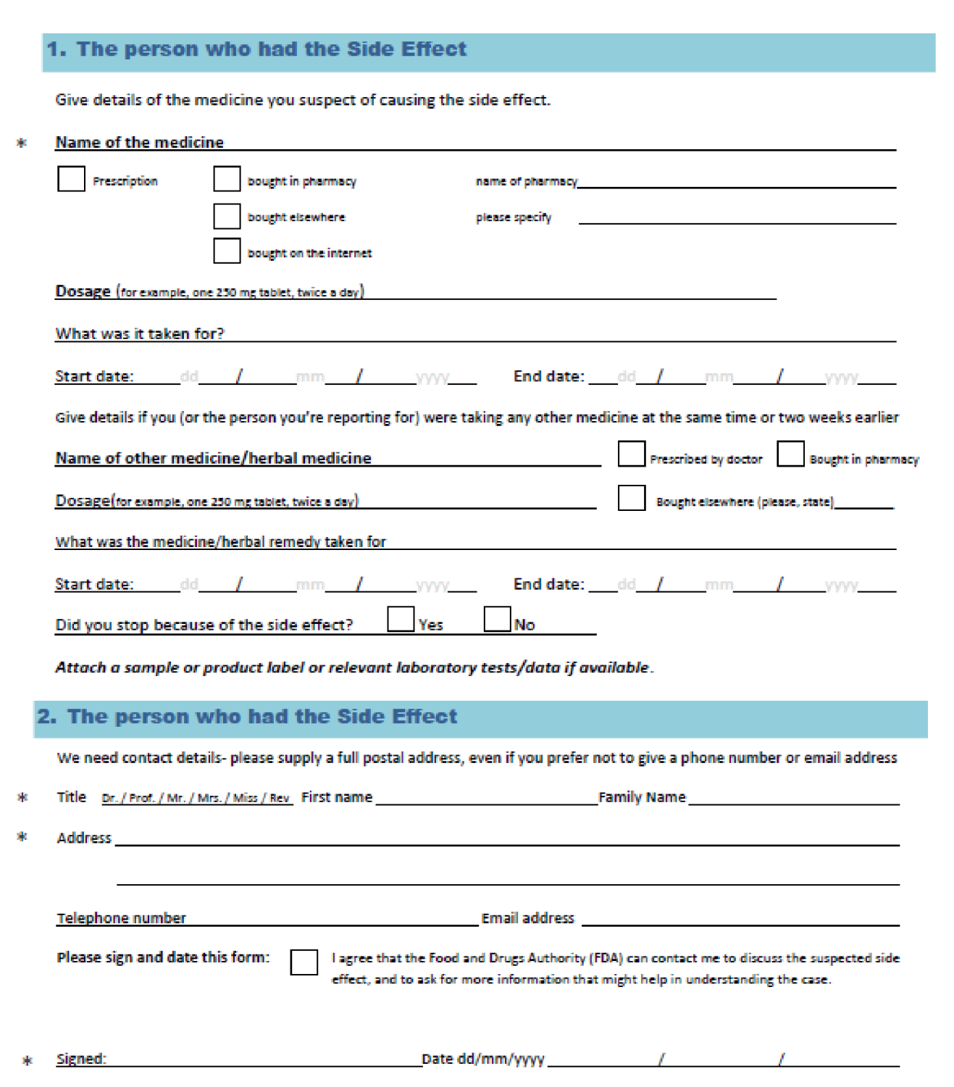
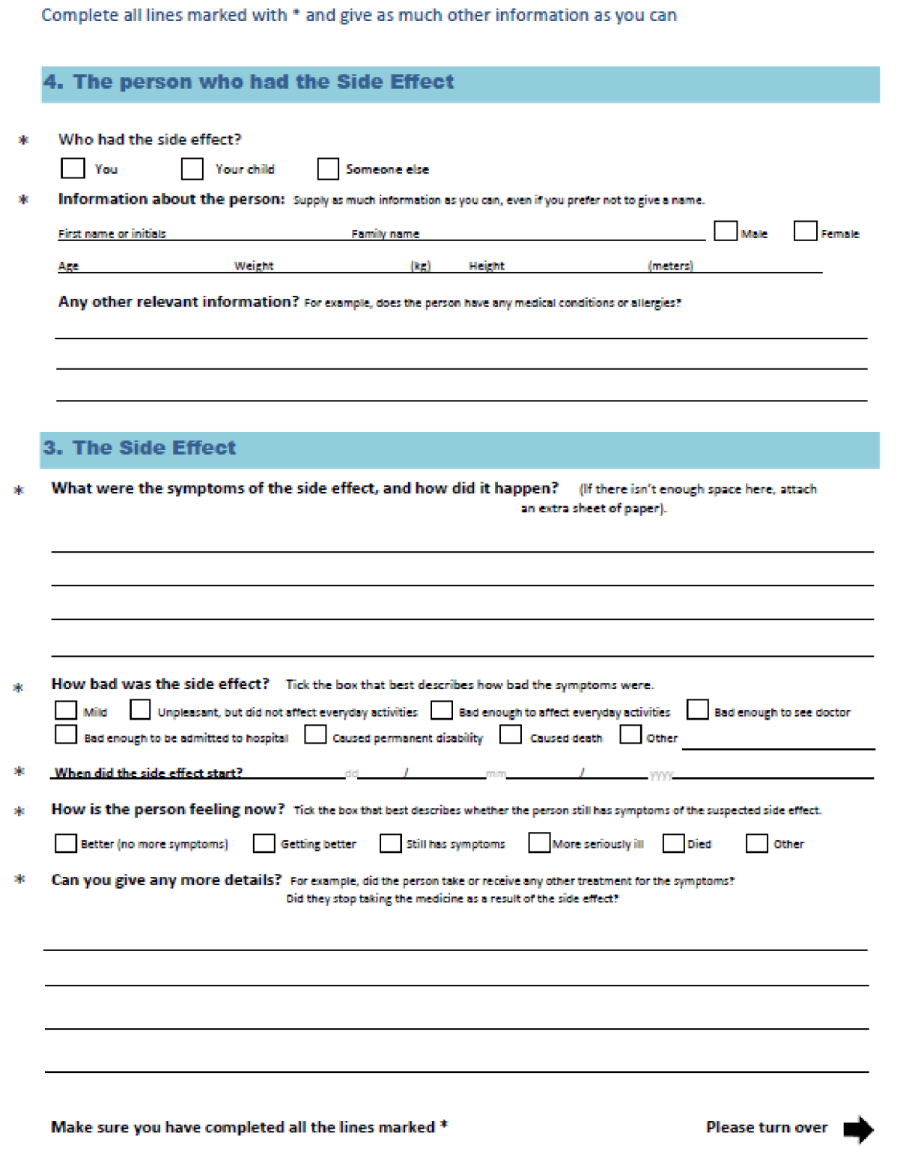

APPENDIX III- Addresses and Contacts of FDA Offices

FDA HEAD OFFICE:
Postal Address:
The Chief executive
Food and Drugs Authority
P. O. Box CT 2783 Cantonments
Accra E-mail Addresses: drug.safety@fdaghana.gov.gh Telephone numbers:
Mobile : 024 4310 297
Landline : 0302-233200, 235100
Fax Number: 0302 225502

Ashanti Regional Office Postal Address:
Food and Drugs Authority
P. O. Box ST 402
Kumasi
Location: Regional Administration Building
Telephone Number: 03220 36070
Fax Number : 03220 36027

Western Regional Office Postal Address:
Food and Drugs Authority
SSNIT building (Near, Central Police Station)
Room 309 Telephone number: 03120 27558 Fax Numbers:
03120 25578

Volta Regional Office Postal Address:
Food and Drugs Authority
PMB, HO

Location: H. No. B6 OPP. GWCL Office Ho Bankoe Telephone number: 03620 26659 Fax Number:
03620 28411

Upper East Regional Office Postal Address:
Food and Drugs Authority
Regional Administration Building Bolgatanga Telephone number:
03820 23727 Fax Number:
03820 24590

Brong Ahafo Regional Office
Sam Bennet Building
Central Market Area
PMB Sunyani Telephone number: 03520 28791 Fax Number:
03520 287 90

Northern Regional Office
Regional Administration Building
PMB Tamale
Telephone/Fax Number
03720 24935
Eastern Regional Office
Hospital Road, Opposite Assemblies of God
Church
P. O. Box KF 2431, Koforidua
Telephone Number
03420 20580 /1

APPENDIX IV- Summary of Timelines and Report Format
TYPE OF SAFETY REPORT | TIME FRAME FOR REPORTING | FORMAT

FDA/SMC/SMD/GL-RAR/2013/01

Local Reports:  Serious unexpected adverse reaction | 7 days | FDA Adverse Reaction  Reporting form (Appendix I) or CIOMS 1 Form
Serious expected adverse reaction | 7 days | FDA Adverse Reaction  Reporting form (Appendix I) or CIOMS 1 Form
Non serious expected and unexpected adverse reactions | 28 days | FDA Adverse Reaction  Reporting form (Appendix I) or  CIOMS 1 Form
Foreign Reports:  Foreign regulatory decisions that affect the safety or use of the product | 7 days | Detailed Report
Literature reports that affect the safety of the product | 7 days | Detailed report plus copy of the publication
Notification of change in nature, severity or frequency of risk factors | 28 days | Detailed report
New information from clinical trials or other studies impacting on benefit-risk profile of product | 7 days | Detailed report
PSURs/PBRERs | For New Chemical Entities (NCEs)  PSURs/PBRERs should be submitted as stated below unless  otherwise requested by the Authority.  - Six (6) monthly for the first two years  - At the time of renewal of the registration of the drug  - Immediately upon request by the Authority | PSUR:- ICH E2C  PBRER:- ICH E2C (R2)

Page 29 of 29

