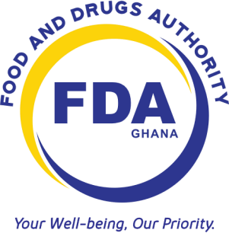
REGISTRATION REQUIREMENTS – Locally Manufactured Food Products
- Purchase forms (GH ¢5) at an FDA office or download one on our website (www.fdaghana.gov.gh) for free and complete registration forms

- Application letter to: THE CHIEF EXECUTIVE FOOD AND DRUGS AUTHORITY
          - ACCRA

- Copy of Business Registration Certificate.
- Copies of Food Handler’s Certificates
- Certificate of Analysis for each product and each variant where applicable
(Should be endorsed by an authorized officer)

- Model labels of the products
- Samples of each product and variants where applicable (see attached sample schedule – FER/RQT-008)
    - Where a product has both Primary and Secondary Packaging, both must be submitted
    - For Mock samples, submit Two (2) sample units
- Licensing of local food production premises (Renewable after every year)
    - Cottage Industry - GH ¢ 50
    - Medium Scale Industry - GH ¢300
    - Large Scale Industry - GH ¢600
- Food Product Registration fee (Renewable after every 3 years)
  - Cottage Industry - GH ¢150 per product/product group
  - Medium Scale Industry - GH ¢ 450 per product/product group
  - Large Scale Industry - GH ¢900 per product/product group
NB:
  - All documents to be submitted for registration must be comb-bound.
  - Applications awaiting additional samples expire after three (3) months from the date of submission of application
  - Only company owners and/or competent company representatives with adequate knowledge of the company must complete the application form.
  - Clearing agents are not allowed to complete the application form.
  - Model labels submitted solely for evaluation attract a fee of GH ¢50.00
  - Name Search for products
o Up to 5 products - GH ¢ 50 o 5 to 10 products - GH ¢ 100 o More than 10 products - GH ¢ 200
  - All submissions made to the FDA should always be accompanied by a cover letter. E.g. submission of additional samples, revised certificate of analysis, variants, payments, responses etc.

